|  |  |
| --- | --- |
| **العربية** | Communication and Electronics Department Analog Communication - EEC 381  Fall 2023 - 2024 |

REPORT

|  |  |
| --- | --- |
| **Name** | **ID** |
| Abdel-Rahman Hesham Mohamed Desoky  Mostafa Mohamed Abdel-Azeem Hassanen  Ahmed Abdel-Hakeem Abdel-Salam Ali  Ahmed Kamel Mohamed Abdel-Gelel  Omar Ayman AbdelAal Shahin | 20012332  20011950  20010124  20010156  19016059 |
|  |  |
| **Section:** | 8 |
|  |  |
| **Department:** | **Communication and Electronics** |

**Experiment One: Double Sided Band Modulation: -**

**Signal in frequency domain:**

Figure : start function responsible for analyzes the input audio file and computes its spectrum.

Figure original spectrum of the signal

**Filtered Signal:**

**Double Sideband Suppressed Carrier:**

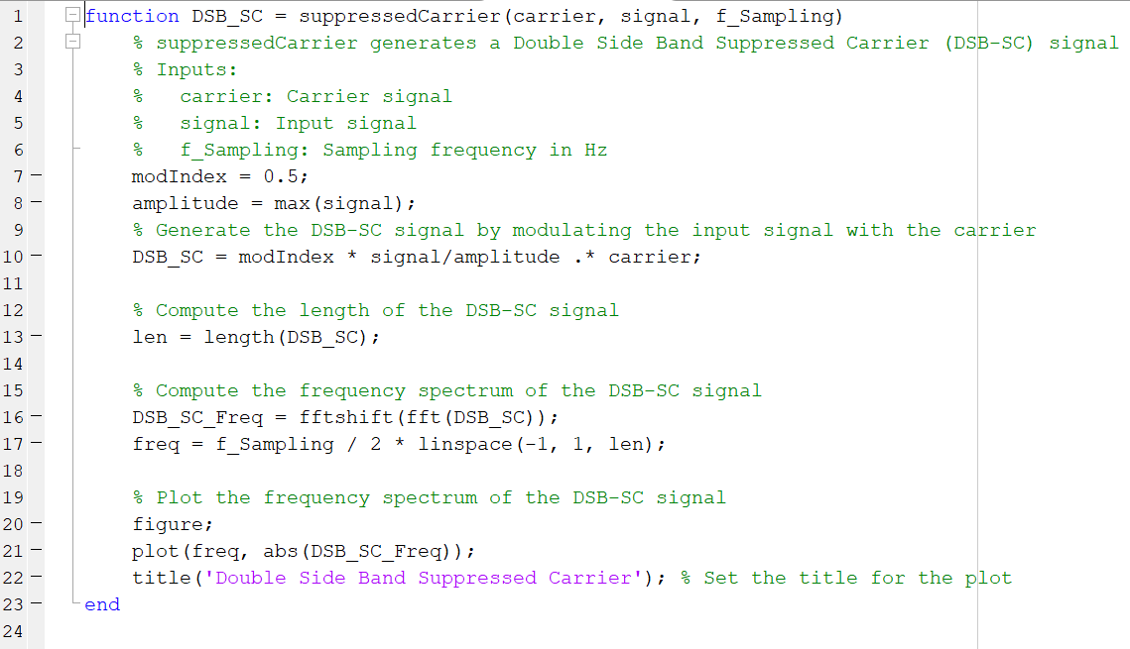

**Double Sideband Transmitted Carrier:**

* **Envelop Detection: -**

-In this point our observations are while playing the sound in case of DSB-SC the sound wasn’t clear and good enough to hear the whole message as there is a lot of attenuation, distortion and phase reversal, in contrast to DSB-TC case the sound was excellent and we can hear the message clearly without distortion or attenuation or phase reversal because of the modulation index which is less than 1, so in summary the envelop detector receiver is much better with DSB-TC but in cases where modulation index is less than (Under modulation) or equal (Critical modulation) 1 other than these cases the envelop detector will be bad choice to receive a DSB signal and coherent detector will be better.

1. **Envelop Detection of Double Sideband Suppressed Carrier:**

1. **Envelop Detection of Double Sideband Transmitted Carrier:**

* **Coherent Detection:**

1. 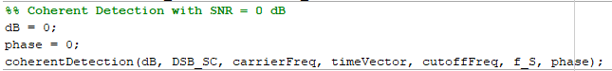**SNR = 0:**

**Signal in Time Domain:**

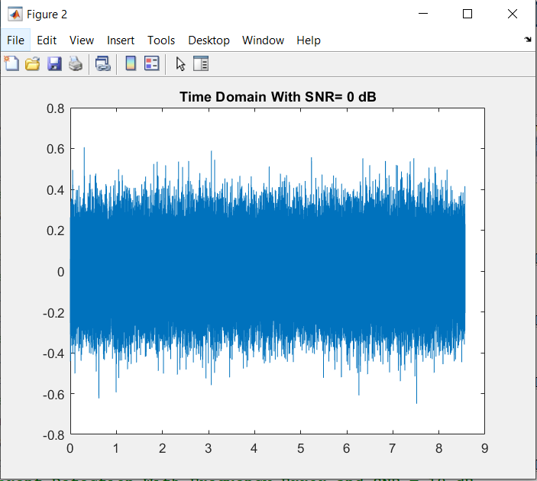

**Signal in Frequency Domain:**

1. **SNR = 10:**

**Signal in Time Domain:**

**Signal in Frequency Domain:**

1. **SNR=30:**

**Signal in Time Domain:**

**Signal in Frequency Domain:**

1. **Frequency Shift and SNR=0:**

**Signal in Time Domain:**

**

1. **Frequency Shift and SNR=10:**

**Signal in Time Domain:**

**Signal in Frequency Domain:**

1. **Frequency Shift and SNR=30:**

**Signal in Time Domain:**

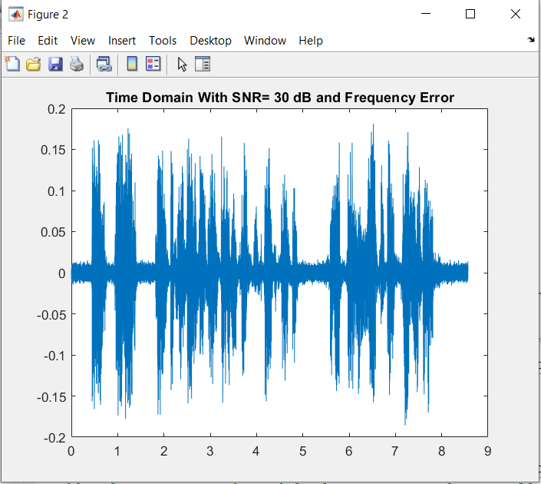

**Signal in Frequency Domain:**

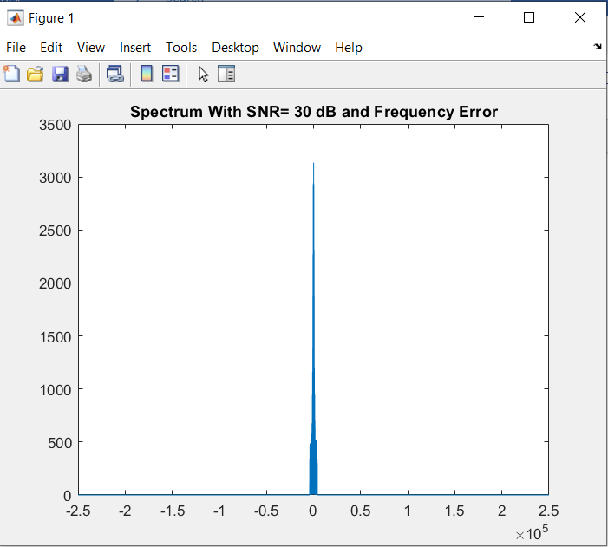

-For proper detection with coherent detector it shouldn’t be any phase or frequency errors between the transmitter and the receiver so in our case we have here shift in frequency which leads to distortion in the received message and this phenomenon is called Beat effect.

***The rest of the page is left blank intentionally.***

1. 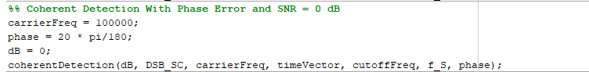**Phase Error and SNR=0:**

**Signal in Time Domain:**

**Signal in Frequency Domain:**

1. 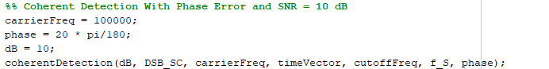**Phase Error and SNR=10:**

**Signal in Time Domain:**

**Signal in Frequency Domain:**

1. 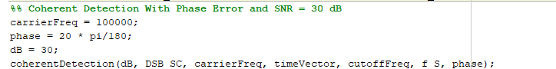**Phase Error and SNR=30:**

**Signal in Time Domain:**

**Signal in Frequency Domain:**

**Experiment Two: Single Side Band Modulation: -**

**Signal in frequency domain:**

**Filtered Signal:**

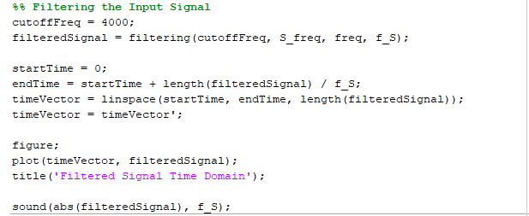

**Filtered Signal in frequency domain:**

**Filtered Signal in Time Domain:**

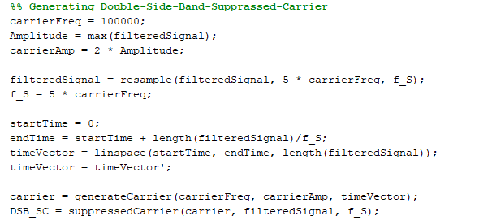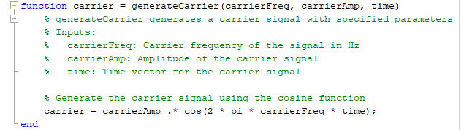**Double Sideband Suppressed Carrier:**

**Single Sided Band (LSB only):**



**Demodulated signal spectrum:**

**Demodulated signal in time domain:**

**Obtaining SSB (LSB) Using a practical 4th order Butterworth filter:**

**Demodulated signal spectrum Using a practical 4th order Butterworth filter:**

**Demodulated signal spectrum Using a practical 4th order Butterworth filter in time domain:**

* 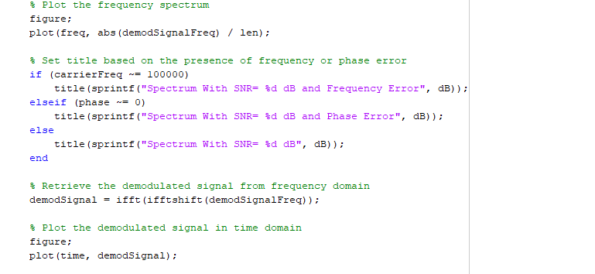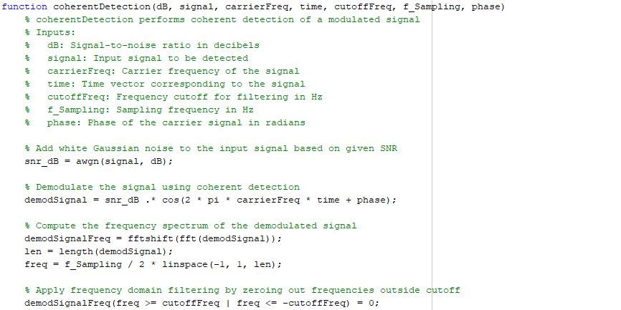**Coherent Detection:**



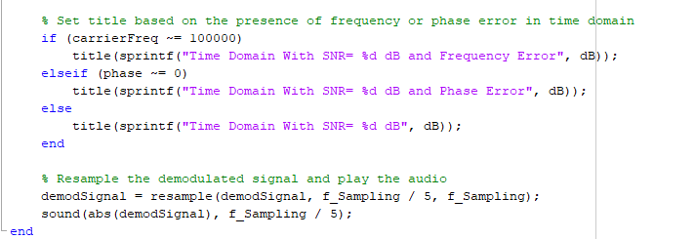

***The rest of the page is left blank intentionally.***

1. **A black text on a white background

   Description automatically generatedSNR = 0:**

**Signal in Time Domain:**

**Signal in Frequency Domain:**

1. **SNR = 10:**

**Signal in Time Domain:**

**Signal in Frequency Domain:**

1. **SNR=30:**

**Signal in Time Domain:**

**Signal in Frequency Domain:**

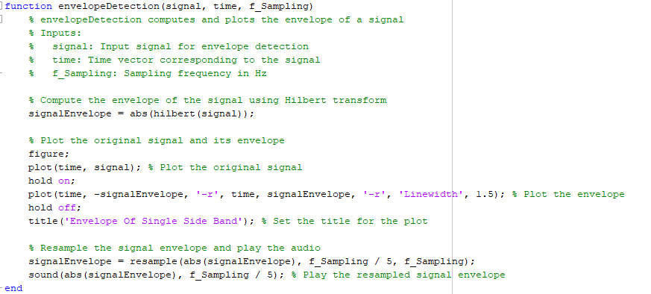**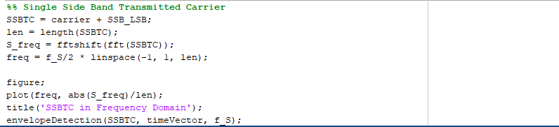Single Sided Band Transmitted Carrier:**



**Demodulated signal using Envelop detection:**

**Experiment Three: Frequency Modulation: -**



**Signal in frequency domain:**

**Filtered Signal:**

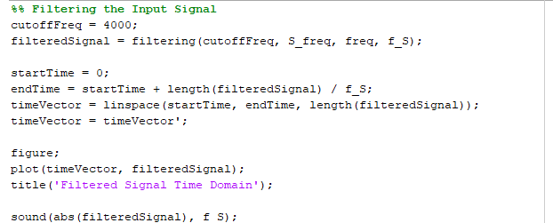

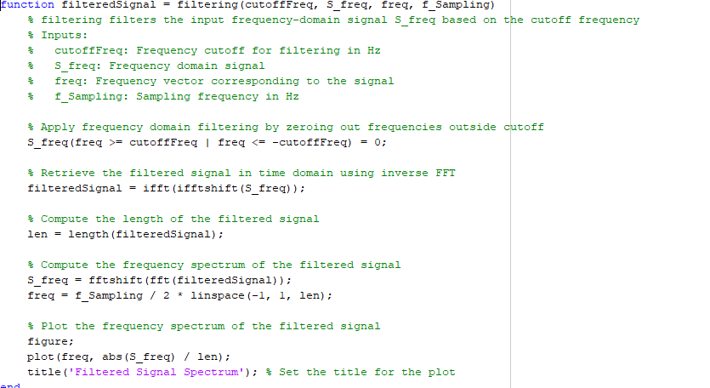



**Filtered Signal in Time Domain:**

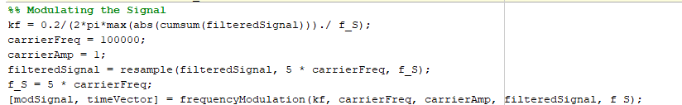**Modulated NBFM signal in Frequency Domain:**

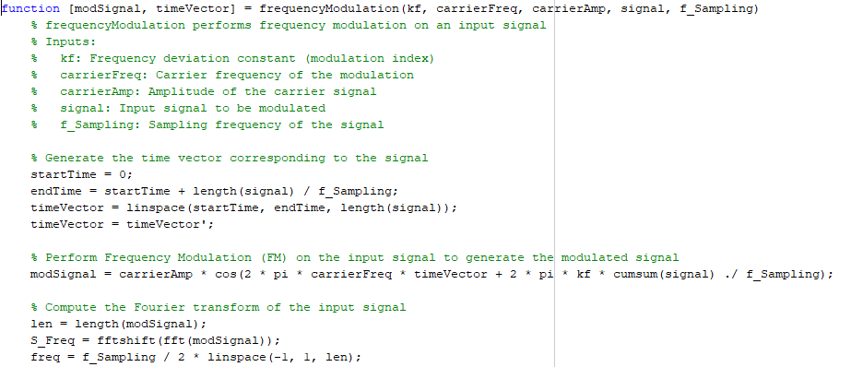

-we notice that the resulting spectrum shape is almost like DSB-TC with bandwidth equal .

-According to Carson’s rule:

So, the condition to achieve narrow band frequency modulation is to have a very frequency deviation which will lead to small frequency deviation ratio (<1) so that its value can be ignored compared to 1 which makes the bandwidth equal double the bandwidth of the message which is like DSB and specially DBS-TC as the carrier is also transmitted.

**Demodulated NBFM signal in Frequency Domain:**

**Demodulated NBFM signal in Frequency Domain**:

**Demodulated NBFM signal in Time Domain**

